Doug Figgs Bio
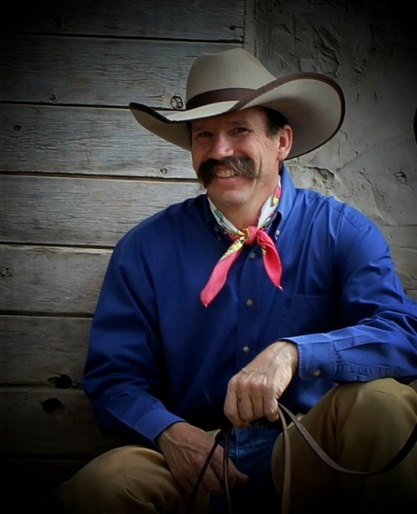
Doug Figgs is an AFA Certified Journeyman Farrier, day working cowboy, and a Western music singer/songwriter from Lemitar, New Mexico. He has won numerous awards for his music including two “Wrangler Awards” from the National Cowboy and Western Heritage Museum along with 2023 IWMA Entertainer of the Year and 2021 and 2018 IWMA Male Performer of the Year. He is inspired by the cowboy/Western life he lives, writing songs from his experiences while drawing from the history of the West. He has performed his music all over the West and continues to turn out his own variety of Western music – from hard driving music with a hint of southern rock, to beautiful ballads, and everything in between.

Doug Figgs
P. O. box 3
Lemitar,NM 87823
505-440-0979 figgspainthorses2@yahoo.com
www.DougFiggs.com

Awards:
- 2023 IWMA Entertainer of the Year
- 2023 IWMA Group of the Year with “The Cowboy Way” trio
- 2022 IWMA Western Album of the Year “Yellow Horse”
- 2022 IWMA Group of the Year with “The Cowboy Way” trio
- 2022 WBFF Best Western Song “Sacramentos”
- 2021 IWMA “Male Performer of the Year”
- 2021 IWMA Group of the Year with “The Cowboy Way” trio
- 2021 “Wrangler Award” Western song “El Caballo del Fuego”
- 2021 “New Mexico Music Awards” Best Cover Song “Ghost Riders/Pipeline”
- 2019 IWMA Western Album of the Year “Go West”
- 2019 IWMA Group of the Year with “The Cowboy Way” trio
- 2019 “New Mexico Music Awards” Best Western Song “I Make My Livin’ in the Saddle”
- 2018 IWMA “Male Performer of the Year”
- 2018 IWMA “Group of the Year” with “The Cowboy Way” trio
- 2018 “New Mexico Music Awards” Best Country CD “…thinkin’ of you”
- 2017 Western Music Association “Group of the Year” with “The Cowboy Way”
- 2017 “New Mexico Music Awards” Best Western Song “A Cowboy Like Me”
- 2017 “Wrangler Award” with the trio “The Cowboy Way”
- 2016 RRMC “Traditional Western Music” CD of the year “A Cowboy Like Me”
- 2015 Academy of Western Artists “Will Rogers Award” Western Male Performer
- 2015 Western Music Association “Songwriter of the Year”
- 2015 Western Music Association “Song of the Year”…….”Socios”
- 2015 “New Mexico Music Awards” Best Western Song “Running With the Wind”
- 2015 WWA “Spur Award” Best Western Song “Charlie and Evangeline”
- 2014 Academy of Western Artists “Will Rogers Award” Western Song “Socios”

